Lab 10: Using a FSM to program a Self-Driving Car Agent

Brandon Trinkle

Arizona State University

Course Number: IFT 360

Professor Durgesh Sharma

10/6/24

**Question 1:** *Downloading and Running the Code*

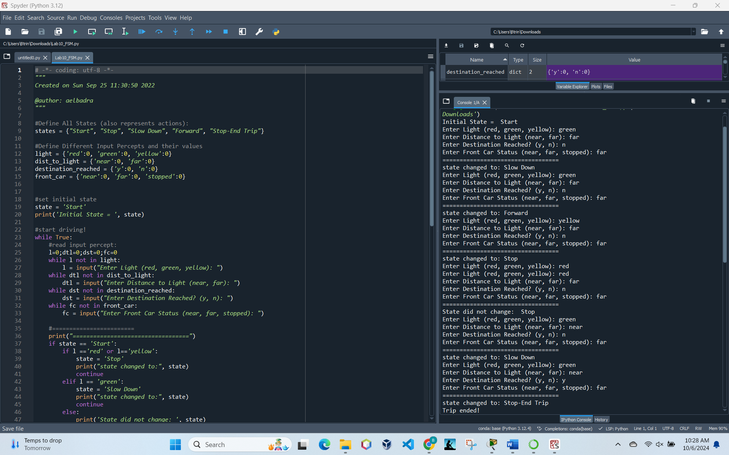

**Question 2:** *Modifying the Code*

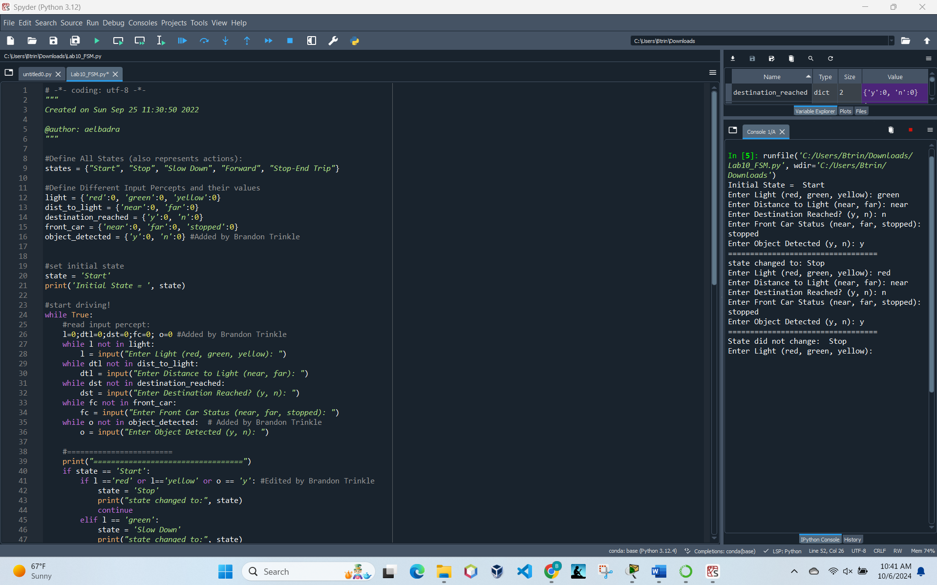

**Question 3**: *Modifying the FSM to account for GPS Commands*



